#include <iostream>

using namespace std;

struct account

{

    char name[10];

    int account_no;

    float balance;

    int count;

};

int main()

{

    struct account *a;

    int c, n, i;

    float money;

    cout << "Enter number of accounts: ";

    cin >> n;

    a = new struct account [n];

    cout << "Enter account details\n";

    for (i = 0; i < n; i++)

    {

        a[i].account_no = i + 1;

        cout << "\nAccount number: " << a[i].account_no << endl;

        cout << "Enter name: ";

        cin >> a[i].name;

        a[i].balance = 0, a[i].count = 0;

    }

    do

    {

        cout << "Choose your option\n";

        cout << "1. Withdrawl\n";

        cout << "2. Deposit\n";

        cout << "3. Check balance\n";

        cout << "4. Exit\n";

        cin >> c;

        switch (c)

        {

        case 1:

            cout << "\nEnter Account number to withdraw: ";

            cin >> i;

            if (a[i-1].account_no < 0 || a[i-1].account_no > n)

            {

                cout << "Invalid account number\n";

                break;

            }

            if (a[i-1].balance < 500)

            {

                cout << "Insufficient balance\n";

                break;

            }

            cout << "Enter amount to withdraw: ";

            cin >> money;

            a[i-1].balance = a[i-1].balance - money;

            a[i-1].count++;

            cout << "Transactions executed: "<< a[i-1].count;

            break;

        case 2:

            cout << "\nEnter account number to deposit: ";

            cin >>i;

            if (a[i-1].account_no < 0 || a[i-1].account_no > n)

            {

                cout << "Invalid account number\n";

                break;

            }

            cout << "Enter amount to deposit: ";

            cin >> money;

            a[i-1].balance = a[i-1].balance + money;

            a[i-1].count++;

            cout << "Transactions executed: "<< a[i-1].count;

            break;

        case 3:

            cout << "\nEnter account number to display: ";

            cin >>i;

            if (a[i-1].account_no < 0 || a[i-1].account_no > n)

            {

                cout << "Invalid account number\n";

                break;

            }

            cout << "The balance is Rs "<<a[i-1].balance<<endl;

            break;

        case 4:

            break;

        default:

            cout << "Invalid input\n";

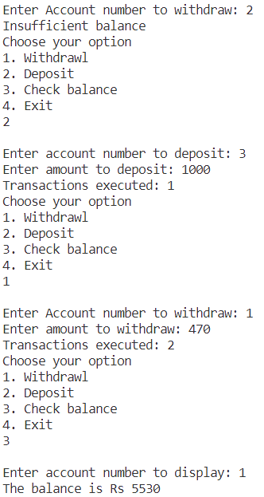        }

    } while (c != 4);

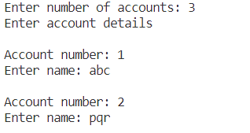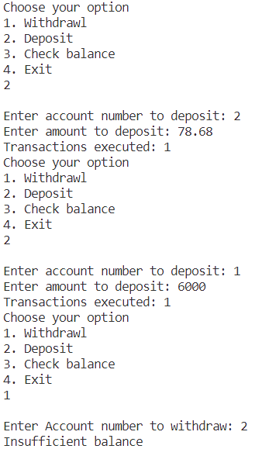}

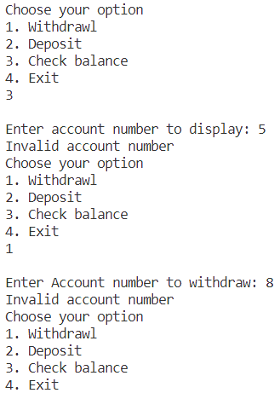

#include <iostream>

using namespace std;

int main()

{

    char name[10];

    int units;

    cout << "Enter the name of the user: ";

    cin >> name;

    cout << "Enter the number of units consumed: ";

    cin >> units;

    float bill = 0;

    if (units <= 100)

        bill = units * 0.6;

    else if (units <= 300)

        bill = 100 * 0.6 + (units - 100) * 0.8;

    else

        bill = 100 * 0.6 + 200 * 0.8 + (units - 300) * 0.9;

    if (bill > 300)

        bill += bill * 0.15;

    cout << "Electricity bill for " << name << " is Rs. " << bill << endl;

    return 0;

}





#include <iostream>

using namespace std;

int main()

{

    int candidate[5] = {0, 0, 0, 0, 0};

    int n, spoilt = 0;

    cout << "Enter the number of ballots: ";

    cin >> n;

    for (int i = 0; i < n; i++)

    {

        int vote;

        cout << "Enter the vote for ballot " << i + 1 << ": ";

        cin >> vote;

        if (vote >= 1 && vote <= 5)

            candidate[i]++;

        else

            spoilt++;

    }

    for (int i = 0; i < 5; i++)

        cout << "Candidate " << i + 1 << " received " << candidate[i] << " votes." << endl;

    cout << "Spoilt votes are " << spoilt << endl;

    return 0;

}

